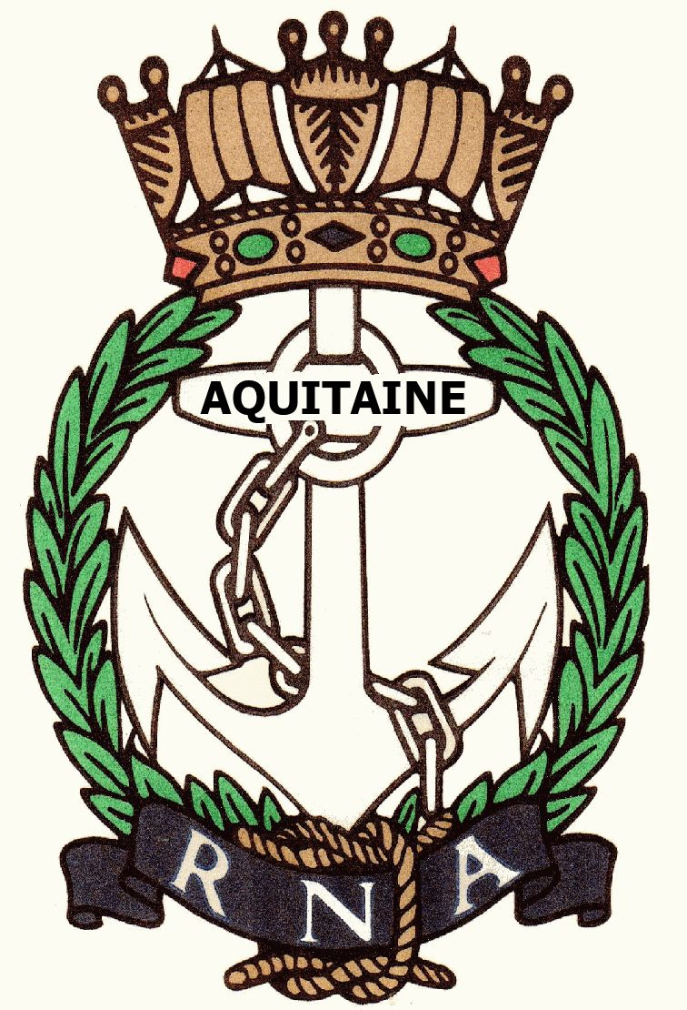
AQUITAINE BRANCH – ROYAL NAVAL ASSOCIATION
Chairman Shipmate Ken Napier MBE
Chazarem, 47290 Beaugas
Email napier.chazarem@wanadoo.fr www.rna-aquitaine.com Tel 05 53 01 70

Aquitaine Branch RNA Chairman’s Report – Mar 2020

On 31 Dec we had a total of 66 members (70 last year), plus one Life (me) and one Honorary. We try to maintain roughly the ratio of 4 full members to 3 associate members but with deaths and people returning to UK this is not always practical. The numbers at 31st December were 41 full members and 25 associate members which approximates to our 4:3 ratio. One shipmate, Dave Pegg, crossed the bar.
This year we have had 12 monthly lunches, numbers are dropping as our membership is ageing, and members find travelling some way for a lunch is too difficult. The membership is more and more spread out. A new Shipmate of our Branch (paid up!) is Captain Bill Oliphant who is the General Secretary of the whole of the RNA – he has a house north of Bergerac.
Most popular remain Trafalgar and Christmas, Liz and Dave Rolfe’s summer lunch was also very popular. Average lunch number was 22. Average cost was 22€. With the rising cost of living it is difficult to keep the cost below 20€. We are always invited by our French AMMAC equivalents to take part in their Assemblées Générales and the lunches which follow.
Thank you to all who helped organise the locations for the lunches, and Brian Johnson for his excellent menus, and maintaining our well visited RNA Aquitaine web site, Don Pike for his Treasurership, Ken Ayling for his support as Vice President and rum bosun, and RNA Aquitaine French postage stamps, Neil Wilde for parading the Standard and Liz Rolfe for her welfare role with various cards. Don is looking for a relief as Treasurer at the end of this year, and we are also looking for an Assistant Secretary. These posts are not onerous but are very necessary to the running of our Branch.
The RNA’s central monthly newsletter can also be found on their web site, it hasn’t been distributed on paper for three years. The password is “Shipmate”.
The drop in membership numbers gave less income from subs and raffle tickets, leaving less for cards, champagne or flowers for members celebrating events and also Charitable donations.
We remain twinned with RFA WAVE RULER but despite being relatively new she has been “resting” in Birkenhead.
Our officially affiliated serving RN man is Captain Darren Houston, who has kept us up to date this year with HMS PRINCE OF WALES. He was promoted to Captain as he left HMS QUEEN ELIZABETH and was briefly Captain in charge of destroyers and frigates based in Portsmouth. The new Captain of QUEEN ELIZABETH left the Navy, was replaced by the Captain of the POW and Darren was transferred to POW. She continues with her trials, and should be taking on fixed wing aircraft shortly. Darren reports she is slightly faster than QUEEN ELIZABETH! Both ships are big, we passed them alongside four weeks ago, the POW was about to sail. The ships are so big that they have to be particularly careful when they sail in windy weather.
Our involvement with FREMM AQUITAINE has come to an end due to lack of response on their part.
Formal events: Our Standard has been formally paraded at Bergerac on the 8th May and Remembrance Day 11th November by Neil Wilde; A Poppy Wreath was laid on both occasions.
It was decided at the last AGM that due to falling interest in the library and no-one willing to take it on that the library itself would be dismantled. Over the course of the year the last of the library books have been disposed of, but more keep coming in – we had a number of John Hudson’s books, he was clearing his shelves before returning permanently to UK.
My thanks to everyone attending today. Your support is important.
Yours aye,
Ken Napier 11 March 2020

